# Project Details

|  |  |
| --- | --- |
| Project Name | Placement Engine |
| Duration | 6 months |
| Team Size |  |
| OS | Windows 7 & Linux |
| IDE& Other tools | Eclipse, Navicat, Beyond Compare |
| Versioning System | Tortoise SVN |
| Database | MySQL |
| Web Server | Tomcat 7.0 |
| Server side Languages& other tools | Java 7, JDBC, JSP 2.2, Servlet 3.0.1, Java Mail, File Upload |
| Client Side Languages & Other tools | HTML, XML, CSS, JavaScript, AJAX, JQuery, Bootstrap, Font Awesome |

# Brief Summary

It’s a web based project developed for the company **US based company**.

Placement Engine is a recruitment service provider specializing in placing the IT professionals in Major Investment Banks and Hedge Funds. Its purpose is to automate the recruitment process that helps employers find qualified candidates to fill full-time jobs throughout the United States. Our employment services encompass all levels of professional IT experience and span a broad range of Major Investment Banks and Hedge Funds.

There are 3 major sections in this project: **Employers**, **Job Seekers**, and **Administrator**.

# UI Mock Ups

### Home Page

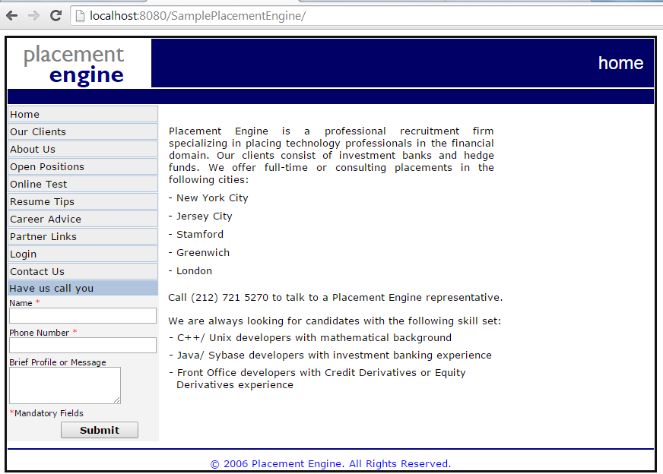

### Client Page

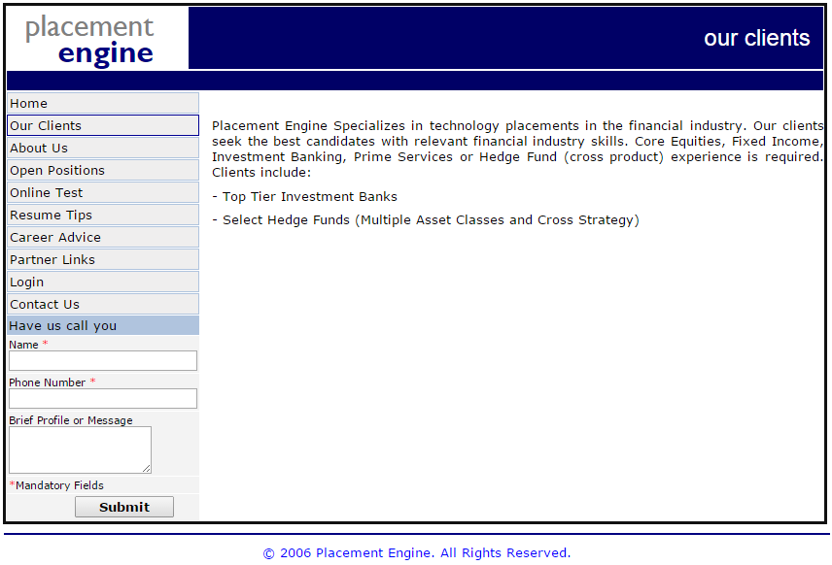

### About us Page

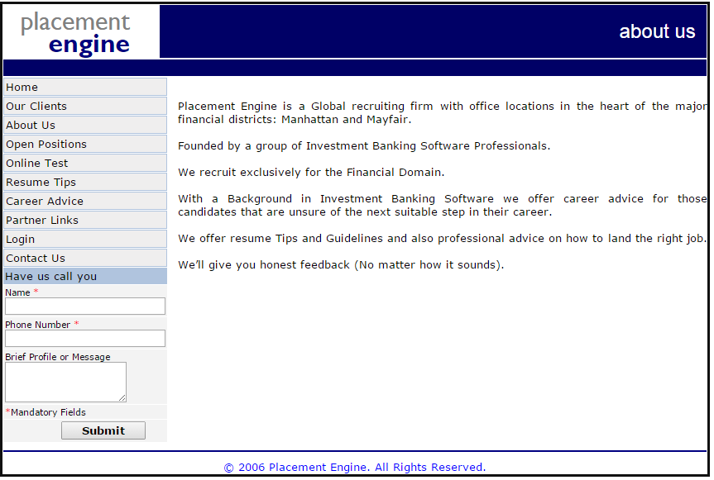

### Open Positions Page

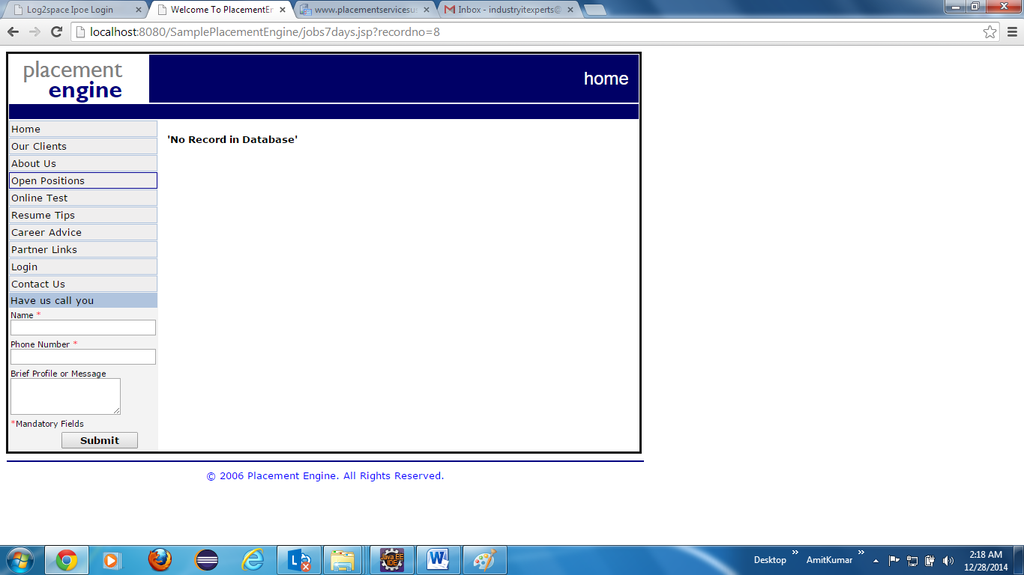

### Resume Tips Page

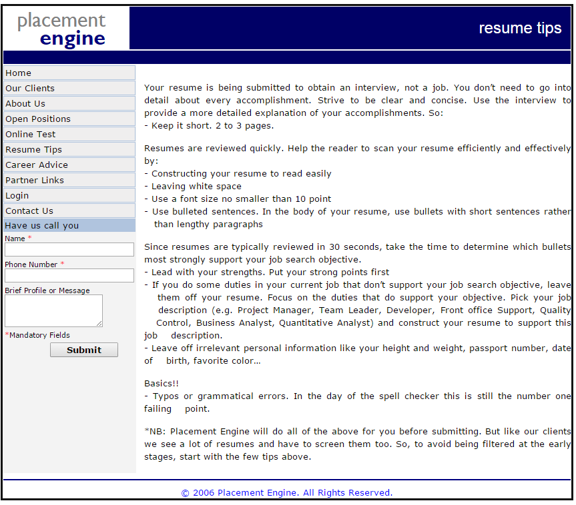

### Career Advice Page

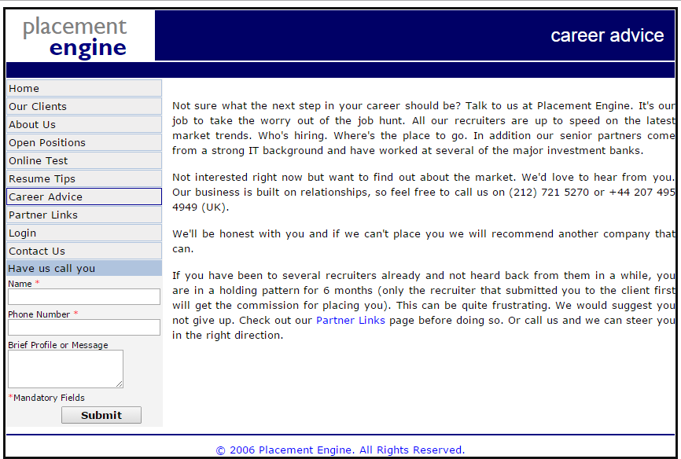

### Partner Links Page

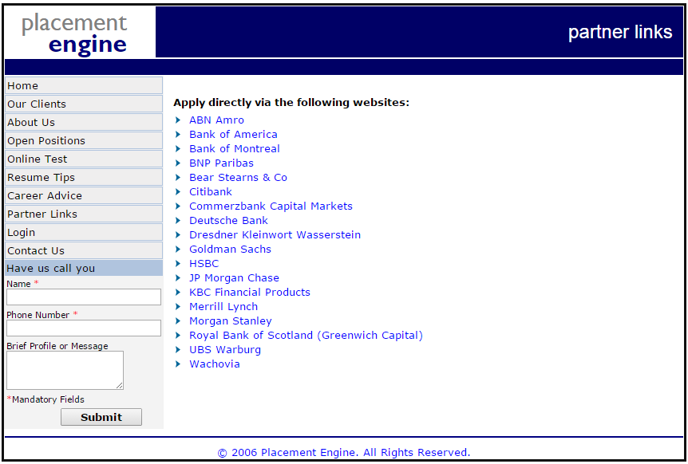

### Login Page

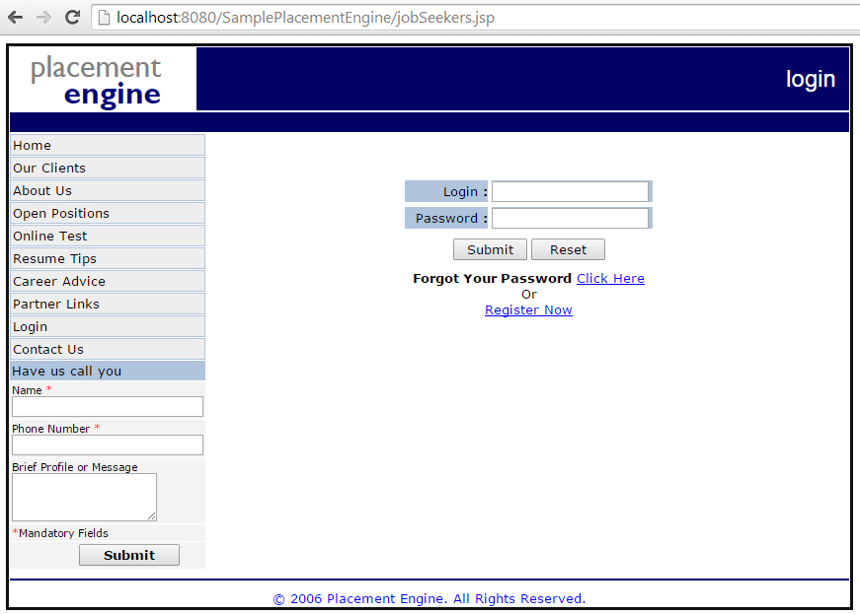

### Contact us Page

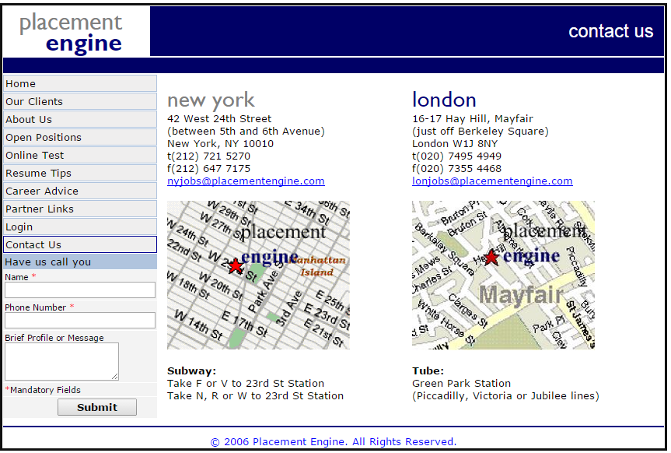

### New User Registration Page

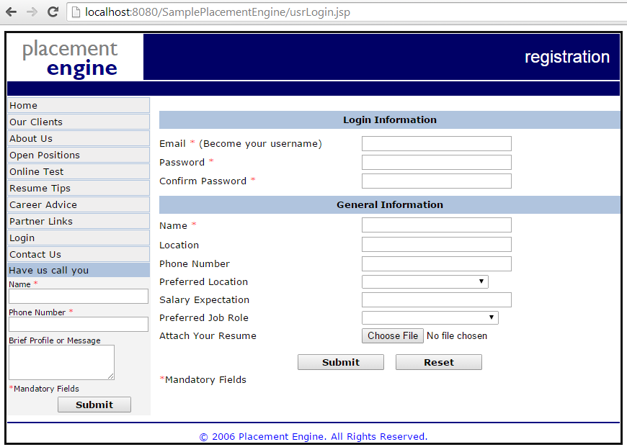

### Forget Password Page

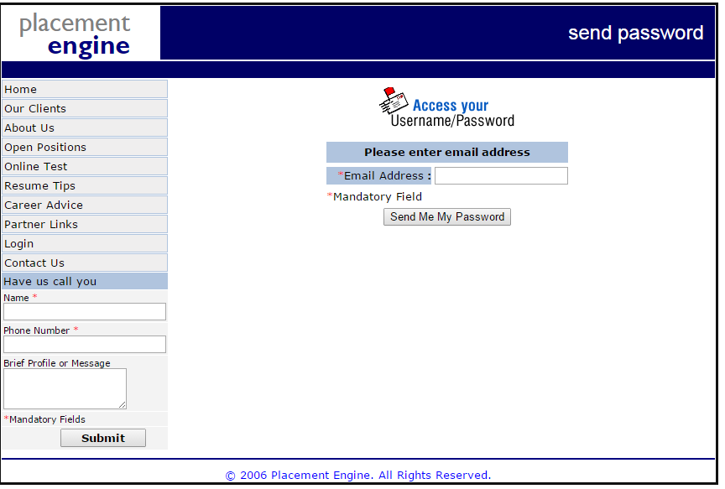

**Definitions, Acronyms and Abbreviations**

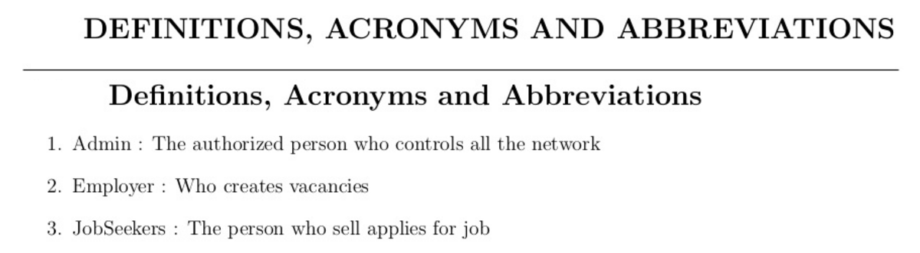

**Requirement Analysis -> Functional Requirement**

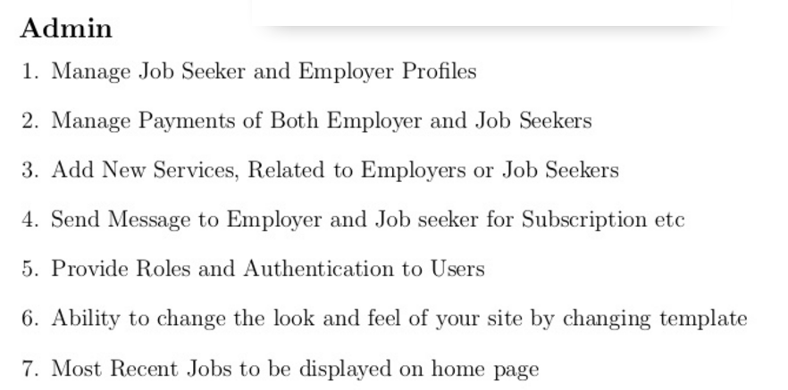

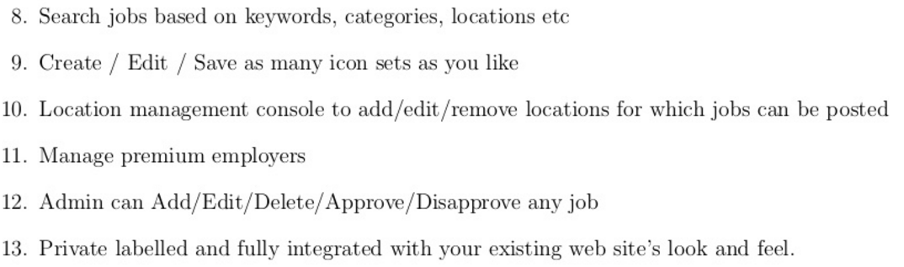

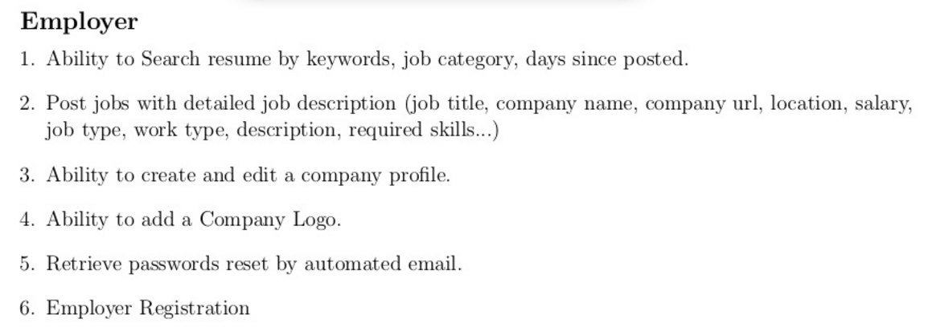

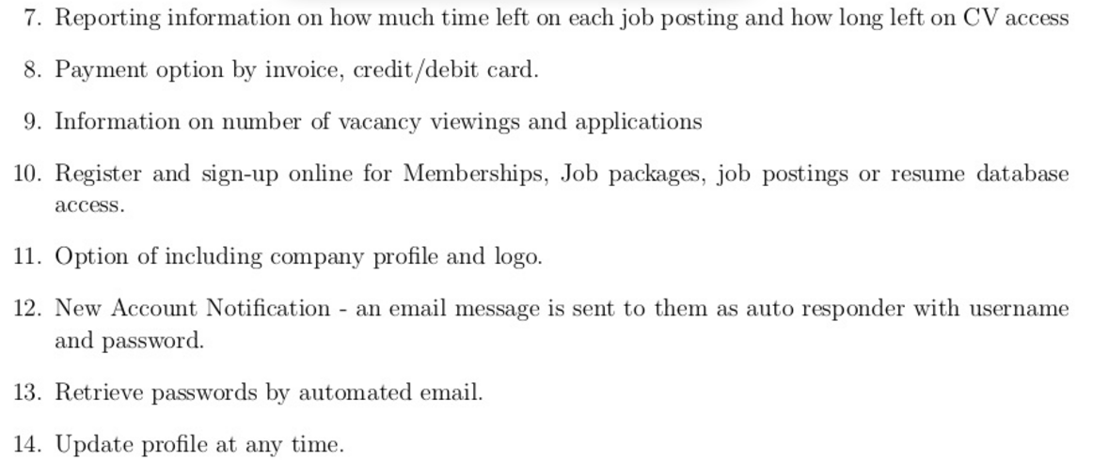

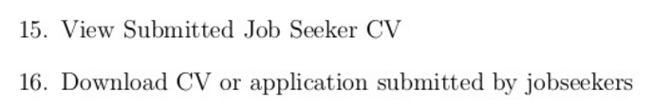

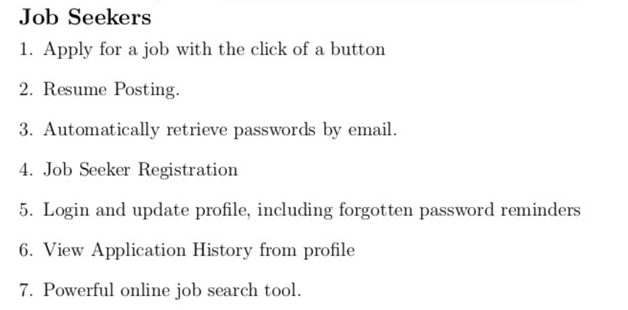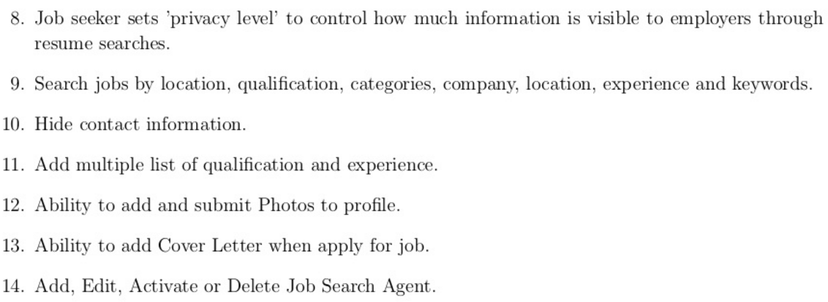

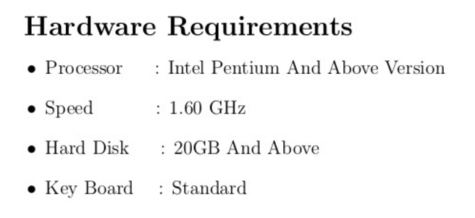

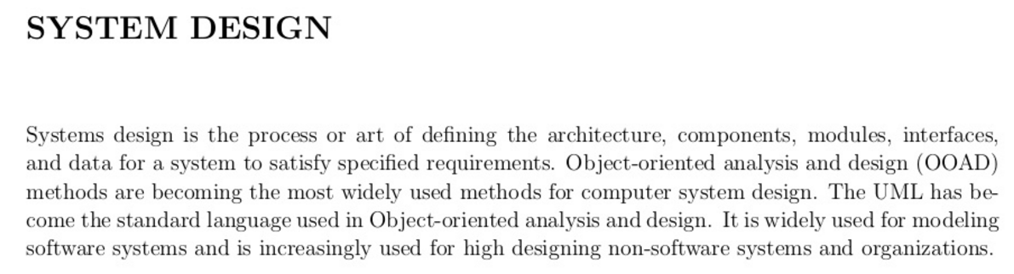**Use Case Diagram**

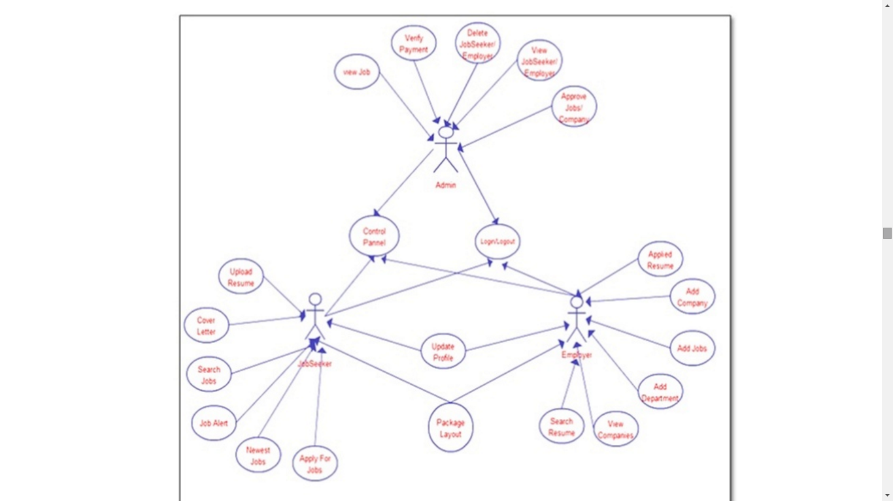

**Sequence Diagram**

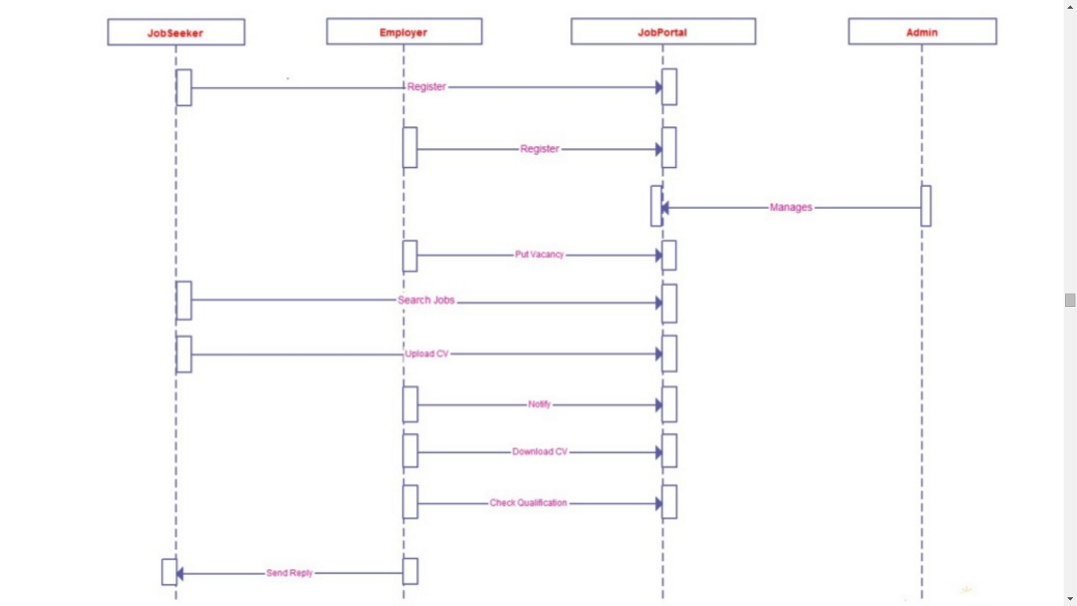

**Level 0 DFD**

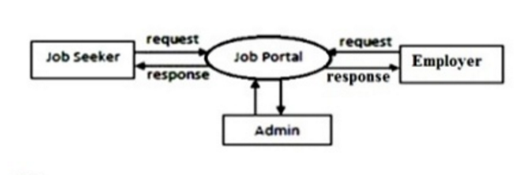

**Level 1 DFD**

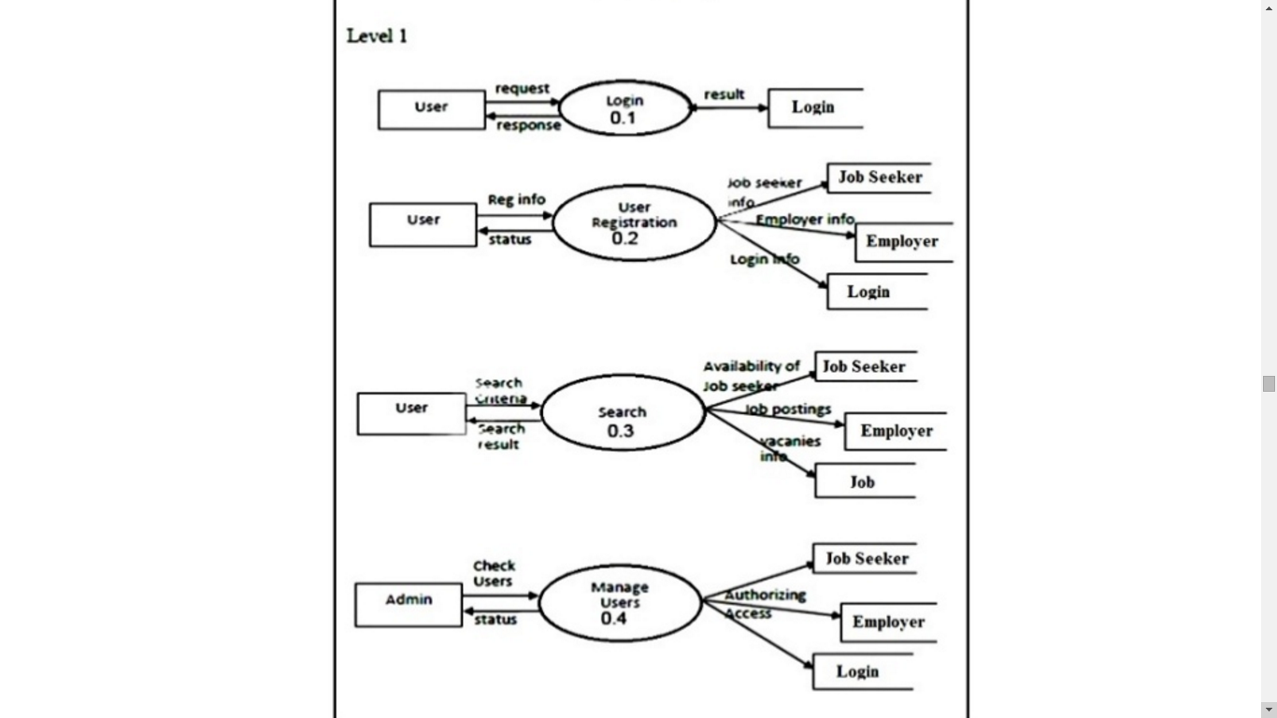

**Level 2 DFD**

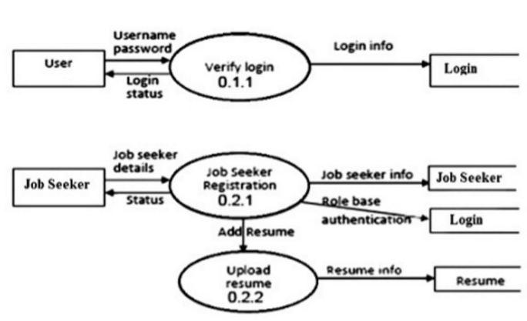

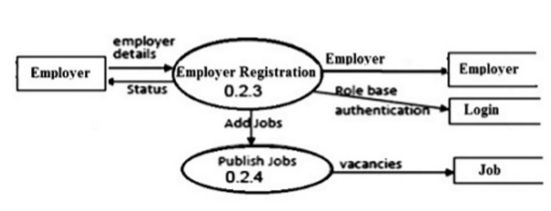

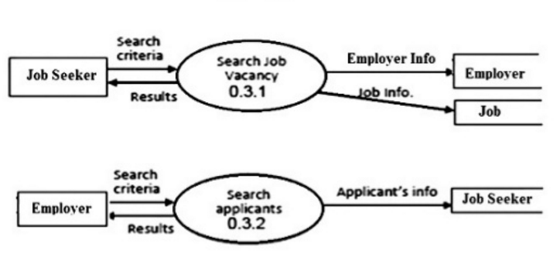

**ER Diagram**

